**Chi-square Analysis**

**Introduction:**

There are two types of chi-square tests. Both use the chi-square statistic and distribution for different purposes:

* A chi-square goodness of fit test determines if a sample data matches a population.
* A chi-square test for independence compares two variables in a contingency table to see if they are related. In a more general sense, it tests to see whether distributions of [categorical variables](http://www.statisticshowto.com/what-is-a-categorical-variable/) differ from each another.
  + A very small chi square test statistic means that your observed data fits your expected data extremely well. In other words, there is a relationship.
  + A very large chi square test statistic means that the data does not fit very well. In other words, there isn’t a relationship.

Chi-square test can be used for checking variable independencies, Homogeneity, goodness of fit.

A chi-square statistic is one way to show a relationship between two [categorical variables](http://www.statisticshowto.com/what-is-a-categorical-variable/). In statistics, there are two types of variables: numerical (countable) variables and non-numerical (categorical) variables. The chi-squared statistic is a single number that tells you how much difference exists between your observed counts and the counts you would expect if there were no relationship at all in the population.

There are a few variations on the chi-square statistic which one you use depends upon how you collected the data and which hypothesis is being tested. However, all of the variations use the same idea, which is that you are comparing your expected values with the values you actually collect. One of the most common forms can be used for [contingency tables](http://www.statisticshowto.com/what-is-a-contingency-table/):

[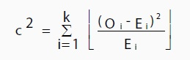](http://www.statisticshowto.com/wp-content/uploads/2013/07/chi-square.jpg)

Where O is the observed value, E is the expected value and “i” is the “ith” position in the contingency table.

A high value for the chi-square statistic means there is a high correlation between your two sets of data. Deciding whether a chi-square test statistic is “large enough” isn’t as easy it seems. It would be nice if we could say a chi-square test statistic >10 means a correlation but unfortunately that isn’t the case. Being able to decide whether the statistic is large enough requires you to have a good grasp of hypothesis testing.

In order to decide if your test value is high enough, first state the [null hypothesis](http://www.statisticshowto.com/what-is-the-null-hypothesis/) and the [alternate hypothesis](http://www.statisticshowto.com/what-is-an-alternate-hypothesis/). Then generate a chi-square curve for your results along with a p-value

The Chi-square Test for Association which is a non-parametric test; therefore, it can be used for nominal data too. It is a test of statistical significance widely used bivariate tabular association analysis. Typically, the hypothesis is whether or not two populations are different in some characteristic or aspect of their behavior based on two random samples. This test procedure is also known as the Pearson Chi-square test.

**Example:**

First case

* Is your manager’s mood associated with the weather?

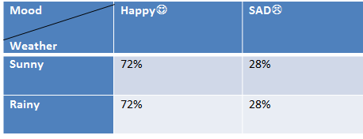

* This appears to be no association between your manager’s mood and the weather here because the row percentages are in same in each column.

Second case

* Is your manager’s mood associated with the weather?

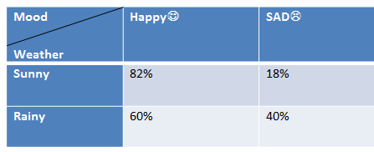

* There appears to be an association here because the row percentage is different in each column.

**Additional information:**

The Chi-square statistic can only be used on numbers. They can’t be used for percentages, proportions, means or similar statistical value. For example, if you have 10 percent of 200 people, you would need to convert that to a number (20) before you can run a test statistic.

**Interview Questions:**

1. [What is a Chi Square Test?](http://www.statisticshowto.com/what-is-a-chi-square-statistic/#chisquareqtest)
2. [What is a Chi-Square Statistic?](http://www.statisticshowto.com/what-is-a-chi-square-statistic/#chi-square statistic)
3. [How to Calculate a Chi-Square Statistic by Hand](http://www.statisticshowto.com/what-is-a-chi-square-statistic/#calculate chi-square)
4. [How To Test a Chi Square Hypothesis](http://www.statisticshowto.com/what-is-a-chi-square-statistic/#chihypothesis)
5. [Chi Square P-Values.](http://www.statisticshowto.com/what-is-a-chi-square-statistic/#chisquarep)